Math and AI: a counter-statement

C. K. Raju

AI threatens the privileges of only those (axiomatic) mathematicians who offer no practical value to society, but make math difficult.

Abstract. The statement by 25 Fields medallists and 8000-odd endorsers deceives people into thinking that axiomatic mathematics is universal. Axiomatic mathematics, or Western ethnomathematics brought by colonialism, differs from pre-colonial non-Western mathematics, even as regards 1+1=2. A key difference is that axiomatic mathematics prohibits the empirical, whereas, for example, Indian ganita accepts it, as does science. Prohibiting the empirical was politically convenient for Christian rational theology, which first used axiomatic proof to “rigorously” prove conclusions about angels, and other empirically non-existent entities. Its true origins are masked by spreading the myth that axiomatic proof originates from a non-existent Euclid. However, the “Euclid” book, despite its “reinterpretation” by the Crusading church, has no axiomatic proofs but does have Neoplatonic diagrammatic proofs, involving a philosophy cursed by the post-Nicene church.

Anyway, the purported superiority of Western ethnomathematics is not about practical value, for the West traditionally despised the practical value of math from Plato through Boethius to Hardy. Therefore, for practical value, Europe was forced to import much of Indian ganita: arithmetic, algebra, calculus, probability. However, Europeans failed to properly understand this imported/stolen knowledge. It is one thing that Western ethnoarithmetic (“Roman numerals”) was grossly inferior, even for simple counting, from early Greek and Roman times. But even after importing Indian arithmetic in the 10th c., to count better, Europeans struggled to grasp subtraction until the 19th c. Because of hubris, they kept asserting the superiority of their inferior pebble arithmetic for centuries. Do you still trust their claim that axiomatic mathematics is “superior”? Examine it carefully!

Axiomatic mathematics cannot provide practical value because it prohibits the empirical. Prohibiting the empirical has political value, for it makes everything in axiomatic mathematics, from axioms on, dependent on Western authority. However, Western authority is not honest as shown by the case of a Fields medallist who repeatedly plagiarized my published research exposing Einstein’s mistake. He was supported by the American Mathematical Society.

This is not an individual case. Numerous harmful lies and superstitions are stuffed into the core of axiomatic mathematics or Western ethnomathematics. Dishonest axiomatic mathematicians have long tried to suppress their exposure. They have also persistently dodged a debate on, for example, the possibility that pre-Newtonian Indian calculus was superior and easier. They use bad arguments such as personal attacks on me based on lies, or misrepresentations, or using one myth to support another, etc., and have never addressed the substance of my critique, and proposed alternative,

Since axiomatic mathematicians will keep dodging, it is for people to agitate to block state support for them, for it is the Western ethnomathematicians who are severely misaligned with society and harm children. We should welcome that AI has demonstrated their unimportance, even for their wretched business of proving useless theorems.

Table of Contents
Introduction 2
Mathematics is NOT universal 2
The rhetoric of “superiority”: from padres, not only Macaulay 5
Western ethnomathematics traditionally despised practical value 8
Western pebble arithmetic was grossly inferior: The Funny History of Arithmetic 11
Why axiomatic mathematics CANNOT provide practical value: it prohibits the empirical 18
How honest is mathematical authority? How a Fields medallist brazenly plagiarised my research 22
The lies and superstitions of the axiomatic math brought by colonial education 25
The harmful effects of axiomatic mathematics 28
How axiomatic mathematics corrupts science 29
Decolonised calculus and statistics 32
Concluding remarks 33

Introduction
The latest to feel threatened by AI are professional mathematicians, after AI outperformed them to resolve several long-standing problems of axiomatic mathematics. Their livelihoods, privileges and prestige threatened by AI, these axiomatic mathematicians, 25 Fields medallists, have issued a declaration endorsed by some 8000 others saying that AI is "misaligned" with mathematics.

The present statement expresses a contrary viewpoint. It is these axiomatic mathematicians who are misaligned with society at large. Therefore, unlike other professions, we should welcome the way AI has reduced axiomatic mathematicians to insignificance.

Mathematics is NOT universal
The declaration lacks honesty. The first lie is the false assumption that there is only one kind of mathematics, from which all the benefits of mathematics derive, and this is the kind of mathematics for which the Fields medal is given and from which these Fields medallists derive their livelihoods and their social power and privilege, now threatened by AI.

This kind of mathematics (Western ethnomathematics) was globalised by colonial education. It is NOT universal since it is fundamentally different from the kind of mathematics that prevailed before colonialism, such as ganita in India. The Indian Class 9 NCERT school text, in its chapter 5 on “Introduction to Euclid’s Geometry”, also says that the Greeks did a superior kind of (axiomatic) mathematics.

Whether or not Euclid existed (he did not) and whether or not there are any axiomatic proofs in the book attributed to him (there are none), the immediate point is this: the text taught students that there are two kinds of mathematics: a “superior” kind done by the West and an inferior kind done by the rest. So even school texts teach that mathematics is NOT universal; there are at least two kinds of mathematics: a purportedly superior kind from the West and an inferior kind from the rest, whether or not such a supremacist claim is true. (It is not.) So why does the declaration lie that there is only one kind of mathematics and that they are its rightful representatives? Obviously, to erase the voices of the colonised, whose math they have long been calling “inferior”.

Once it is admitted that mathematics is not universal, that the mathematics which existed in pre-colonial times, for millennia, was different from the mathematics globalised by colonial education, the colonised may want to decolonise, irrespective of how much such an attempt may and does enrage the West. Such Western rage is of no consequence considering the huge genocides during colonialism (estimated at over 50 million in India). We may want to reject these padreist lies and to choose the kind of mathematics which is actually better, meaning superior in terms of practical value, rather than going by padreist myths and cultural and religious superstitions.

As we will see, axiomatic mathematicians have been dodging a debate on this question for over a decade. The impugned declaration excludes any debate by trickery, simply pretending that there is no choice to perpetuate a key evil of colonialism (that the West invented a “superior” form of mathematics), closely linked to the racist superstition of superiority. I strongly suggest that you should first read both parts of this article initially given as an inaugural keynote address at a joint meeting of the Universities of Pretoria and Tübingen: “‘Euclid’ Must Fall: The ‘Pythagorean’ ‘Theorem’ and the Rant of Racist and Civilizational Superiority”. Or read the popular-level versions “Why axiomatic math is racist”, and Racism in the math classroom: “Pythagorean theorem” and the two myths of “Euclid”.

When told that mathematics is not universal, the typical first response of the layperson is to laugh and ask, so what can be different? Is 1 plus 1 not equal to 2? This only reflects the extraordinary ignorance of mathematics spread by colonial education. 1+1 was surely 2 in pre-colonial math. What has changed are the reasons why 1+1=2. You perhaps recall the way you were taught it in KG by showing you pictures of two oranges to show that 1+1=2.

This showing of pictures involves observation or the empirical, which is accepted in normal mathematics (or ganita); but the empirical is prohibited in “superior” formal mathematics or axiomatic mathematics that the Fields medallists live by. Before examining the textbook claim of superiority of Western math, whether it is better grounded than the superstitious racist claim of “superiority” based on the colour of the skin, and whether formal mathematics may actually be inferior, let us first understand the difference between normal mathematics and formal or axiomatic mathematics more clearly.

The difference is clear from the fact that Bertrand Russell and A. N. Whitehead, in their Principia Mathematica, took 378 pages to give the first proof of 1+1=2 in axiomatic mathematics. Page 378 is reproduced below.
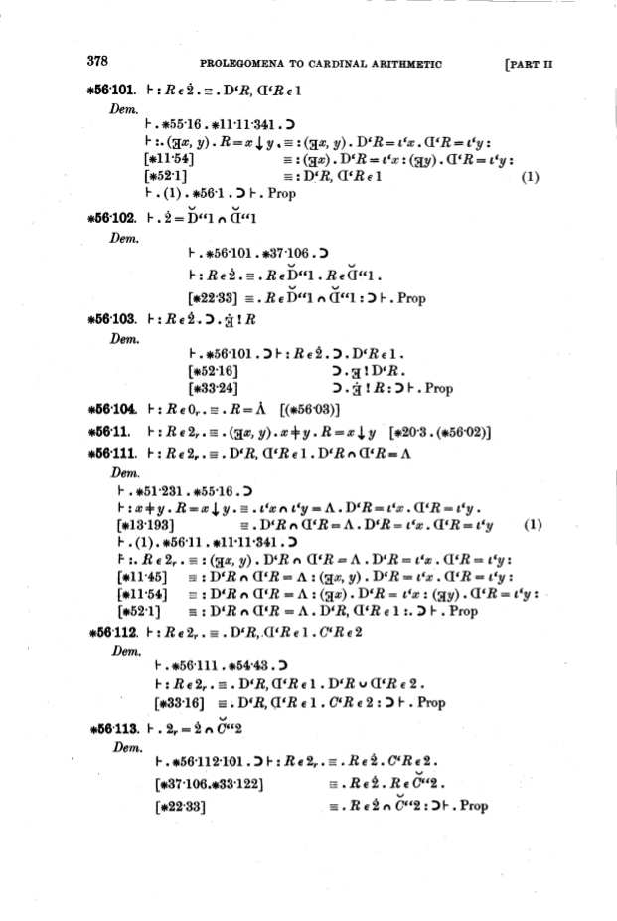

Do you understand even one sentence on that page? No? But this is the kind of extraordinarily difficult and ugly axiomatic mathematics which the signatory formal mathematicians implicitly declare as “universal” but also contradictorily as “superior”. (From contradictory assertions, any desired conclusion may be drawn; hence making contradictory assertions about god was a typical padreist trick of sophistry, to deduce any desired conclusion.)

Actually, proving 1+1=2 in axiomatic mathematics can be much harder. In axiomatic mathematics, the number 1 has no (unique) meaning: the number 1 in cardinals, to which the above proof applies, is different from the number 1 in real numbers (taught in the Class 9 text) because the underlying axioms are different.

Hence, to further illustrate the extraordinary difficulty of even 1+1=2 in axiomatic mathematics, during a video-recorded lecture at the leading Indian university JNU, I offered a prize of rupees 10 lakhs (my Cape Town-JNU challenge prize) to anybody who could similarly prove 1+1=2 in axiomatic real numbers from first principles, without abbreviation, and without assuming any theorems of set theory.

The difference is that defining the axiomatic “real number” 1 needs axiomatic set theory. Unlike most mathematicians, AI can easily give a proof verified by LEAN. But no human has claimed that prize so far. Note the caveat again. One is not allowed to just produce a proof, perhaps generated by AI. One must be able to explain every step in it without consultation. The challenge prize was offered to illustrate the difficulty most humans have in understanding axiomatic math, and not to test the capabilities of AI, which are obviously superior for this task. Indeed, one wonders how many of these 8000-odd endorsers (at last count) are able to do it on their own withOUT the help of “misaligned” AI!

The rhetoric of “superiority”: from padres, not only Macaulay

So, in post-colonial mathematics even 1+1=2 is very different, and far more difficult than in normal (pre-colonial) mathematics. So, why did colonialism promote this kind of extraordinarily difficult mathematics? There was a cultural reason and a political reason.

Culturally, it was claimed that colonial mathematics was “superior”. Such a claim of superiority was made by Macaulay in his 1835 Minute on Education, which spoke of the “immeasurable superiority” of the West in mathematics and science. This boast was followed by the imposition of colonial higher education in India. It created the “Macaulay mindset”, or rather, a padreist mindset, which some colonised desperately want to eliminate by decolonising education, especially mathematics.

One often encounters this rhetoric of superiority, whether Western superiority asserted during colonialism, racist superiority asserted to justify slavery before colonialism, or the Christian superiority asserted still earlier to justify the vast genocides in 3 continents. In this rhetoric, one must recognise the hidden hand of church superstitions, spread by its army of padres, to morally justify the vast evils that resulted. For example, racism or prejudice based on skin colour began as a padreist superstition of the Biblical “curse of Ham”, as a trick to justify continuation of slavery, after many Black slaves mass converted to Christianity, and the White poor exported from Europe objected to continuation of slavery which depressed wages.

We will see the church superstitions in mathematics shortly. The immediate point is that colonial education brought Western education, founded on claims of superiority. But Western education, from Sunday school to the highest Western universities, was created by padres, brought by them to the colonised and spread across the world through their agency.

Macaulay only made explicit the political reason why control of education was so important for colonialism. The padres ruled Europe without weapons, hence with the help of the soft power from lies and superstitions. Padreist education made their lies credible through early-life indoctrination. This made those the padres educated feel inferior and mentally obedient to authority. For colonialism, the important thing was that this mental subjugation controlled revolt. Even for the British poor, Macaulay suggested in the British Parliament in 1847 that padreist education, by mentally subjugating people, was the cheapest means of controlling revolt. “Have you ever seen an educated man revolt?” he asked. In India, while missionary schools and colleges existed since 1501, colonial higher education came in a big way only after the revolt of 1857.

Returning to mathematics, let us ask: why is axiomatic mathematics “superior”? People wrongly imagine it is for superior practical value (“they have sent a rocket to the moon”). But this is completely wrong. It is clear that axiomatic math makes the simplest math of 1+1=2 very difficult. But what added practical value did you get in return for this extra difficulty? What practical value does this complexity of a 378-page proof ADD to the normal mathematics of 1+1=2? None! A cartoon is enough to show this.
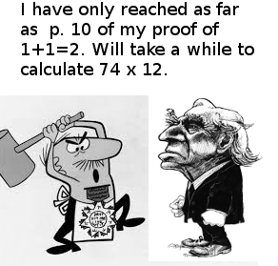

For arithmetic of practical value, you are better off using Indian ganita, repeatedly imported by Europe for its practical value, as described in my book The Funny History of Arithmetic, and discussed in more detail later. Less obviously, that (lack of practical value of axiomatic math) applies also to the calculation of rocket trajectories.

Personally, this lack of practical value was the reason why I abandoned axiomatic mathematics, specifically its lack of practical value for technology development (and calculation of rocket trajectories). Indeed, though I initially trained as an axiomatic mathematician and researched on its applications to physics, and taught it (Real Analysis and Functional Analysis) for many years, I later abandoned it. After resigning from Pune University, I somehow rejected other job offers to continue my math research, and instead joined C-DAC, the challenging Indian supercomputing project, coincidentally soon housed within the same campus. Here, my role was to implement applications of national importance on the target machine, a poor man's parallel supercomputer. Then existing computer programs, written, e.g., for the Cray X-MP 14 supercomputer (with a vector architecture), could not be automatically parallelised: parallelisation required domain-level expertise in mathematics and physics, which I hoped to provide.

But, to my utter surprise, I found that all the things in formal mathematics that I had learnt, and taught and researched on for years, were of little value for any practical applications. Even all the applied mathematicians I consulted only said this: "We have published such and such theorem; you find its practical application". The practical applications did not exist because the proofs of the theorems made assumptions with no basis in reality. It took me some twenty years to digest this complete uselessness of my years of training in axiomatic mathematics, and to unlearn what I had internalised, and to abandon axiomatic mathematics. A divorce after decades.

For those who think a grocery shop is too “inferior” an application of mathematics, and that the above argument from my experience is anecdotal, I later gave a more philosophical argument. This concerns both rocket science (”they have sent a man to the moon”) and AI. Both of these applications involve calculations done on computers. And computers cannot use real numbers; they use floating-point numbers for which even the associative “law” for addition fails. But this “law” is stipulated for all common axiomatic number systems, especially the real number system (wrongly) declared essential for calculus. So the fact is that successful calculation of rocket trajectories entails the rejection of the axioms of axiomatic mathematics, pompously called “laws”. This is true of any of the many practical applications of mathematics for which computers are used. (Calculations by hand, too, are also always done only to a finite precision, unlike the infinite precision fantasized for axiomatic real numbers.)

So the fact of the matter is that to achieve practical value in real life one rejects the axioms of axiomatic mathematics, whether in a grocery shop or to calculate rocket trajectories or do AI.

Indeed, the political, not practical, value of Western prizes is quite obvious, as in the case of the Nobel Peace Prize. Similarly, the Fields medal involves politics and was given to an Iranian woman to put pressure on Iran, especially in the matter of the treatment of women. The economics Nobel helps to leverage the economic policies of a country, just as much as the Fields medal to an Indian has helped to leverage the math education policies of India. (This politics applies also to the Nobel Prize for physics recently given for the mathematics of singularity theory, which has been used to promote Christian creationism as science, as we will see later.)

While there is clear political value to these prizes, the theorems proved by these Fields medallists lack practical value. For example, in a tweet I asked whether the Indian Fields medallist Manjul Bhargava’s math has “the slightest PRACTICAL value for any Indian?” No one knew. Do you?

Western ethnomathematics traditionally despised practical value

Indeed, the lack of practical value is characteristic of Western ethnomathematics.

You should know this if you studied the (compulsory) Indian Class 9 NCERT school text. It clearly asserts the purported superiority of Western ethnomathematics as due to its LACK of practical value and NOT for its practical value. This may not have registered during your school education. So here is the passage from the Class 9 school text below.
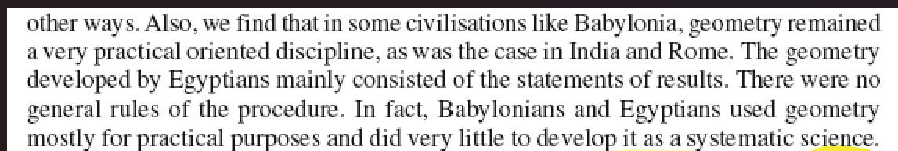
The process of deprecating practical value is no aberration of the Indian school text; it is endemic to Western ethnomathematics and began with Plato, who ridiculed the practical value of geometry (Republic Book VII),

They have in view practice only, and are always speaking in a narrow and ridiculous manner, of squaring and extending and applying and the like --they confuse the necessities of geometry with those of daily life....
Plato ridiculed practical value because he connected mathematics to spiritual knowledge, knowledge acquired by the soul in its previous lives. This is clear from the famous dialogue between Socrates and the slave boy in Plato's Meno, where Socrates uses geometry to prove the existence of the soul, and its past lives. Indeed, the very word “mathematics” derives from mathesis, meaning learning, and learning, according to Plato in Meno, means arousing the soul to make it recollect the knowledge it acquired in its previous lives. “All learning is recollection”. Plato advocated the compulsory teaching of mathematics because of this “soul arousal”, which he believed made people virtuous.

Western philosophy has been called a series of footnotes to Plato. And this passage in Republic decided the character of Western ethnomathematics. It is quoted by the 5th−6th c. padre Boethius who wrote the key influential European book on arithmetic De Arithmetica. This book was so influential since it was used for over a thousand years as part of the church curriculum for padres, the quadrivium. Boethius intended and clearly says that his arithmetic should not have any practical applications. Hence, he refers to the very same dialogue against practical math from Plato and goes on to say:

This, therefore, is the quadrivium by which we bring a superior mind from knowledge offered by the senses to the more certain things of the intellect. … by means of the eye of the minds, which (as Plato says) is of higher dignity…
“Knowledge offered by the senses” refers to empirical knowledge, fatal to church theology, hence declared inferior (and banned also in axiomatic mathematics). Note the stock church trick of declaring it inferior. Note also the fallacious church belief, also found in axiomatic mathematics, that this rejection of the empirical adds epistemic value (“the more certain things of the intellect”).

Naturally, Boethius’ book on Arithmetic has no practical applications, as is freely admitted by Western historians.
It gives no rules of computation, no practical application of arithmetic to daily-life problems, nothing useful or practical in the ordinary sense of those terms. [emphasis added]
Ironically, Western ethnomathematics lost any possible spiritual value too shortly after Boethius when the church pronounced its great curse or anathema on Plato's “pagan” notion of soul, accepted in early Christianity, and replaced it with a notion designed to enhance the political power of the padres over the European mind. While Neoplatonic mathematics did have some beauty to it, that beauty was lost when the church reinterpreted it as supposedly axiomatic mathematics due to an unknown Euclid. Consequently, Western ethnomathematics became “soulless” and ugly as it is today. Hence, billions of schoolchildren, intuitively recognising its soullessness, shun and hate mathematics. and are repelled by the colonial teaching of mathematics. But church superstitions are sticky.
This constant deprecation of the practical value of mathematics by the church padres did not end with medieval times. The 20th c. Hardy in A Mathematician's Apology admits “that very little of mathematics [i.e., axiomatic mathematics] is useful practically”. He replaced Plato's notion of “soul arousal” with a modern euphemism: aesthetic value. He said mathematics (i.e., Western ethnomathematics) is done for its aesthetic value, like that of poetry or painting.
Now, Plato's point was that both music and mathematics “arouse the soul”, hence make people virtuous. But Hardy sadly neglects the church/padreist curse on Plato’s notion of soul and its “reinterpretation” of the notion of the soul to suit its political purpose of padreist domination. Hence, Hardy could offer no explanation for the fact that billions of schoolchildren love music but are repelled by and hate (colonial) mathematics. Why should beauty repel? Obviously, any beauty in elementary math which existed in Plato's time was lost. Anyway, this widespread hatred of mathematics brought by colonial education is an excellent reason why mathematics should be decolonised and made easy.
Nevertheless, this ugly colonial mathematics was globalised because it suited the political needs of the coloniser (by helping the West to dominate mathematical knowledge by making it totally dependent on Western authority), though it did not fulfil any social or practical needs of the colonised.
If we do mathematics for its practical value, then we should decolonise and revert to pre-colonial mathematics, which celebrated practical value as in Indian ganita.
This is still the part of mathematics that offers much practical value to people today, as, for example, in the use of arithmetic for commerce, calculus for rocket science and statistics for data science and AI. The practical value of this kind of normal mathematics, called ganita in India, was celebrated by the 9th-century mathematician Mahavira.
Everywhere in trade, economics, the science of sex, in music [permutations and combinations], in drama, in cooking, in [mixing] medicines, in architecture, in prosody, rhetoric and poetry [metre], in logic and grammar, in all of these ganita is primary. In understanding the motions of the sun, moon, and planets, the eclipses and the conjunctions, to answer the three questions [time, place, and direction] ganita is everywhere useful. Islands, oceans, mountains, their number their diameters and perimeters [all require ganita]...

Western pebble arithmetic was grossly inferior: The Funny History of Arithmetic
In this case of mathematics, Western practice ironically matches its precept. In keeping with the constant condemnation of the practical value of mathematics, Western ethnomathematics, since its very beginning, has been “immeasurably inferior” in terms of practical value.
Indeed, most of the mathematics of practical value that you learn in school today originated in the non-West: arithmetic, algebra, trigonometry and calculus, probability and statistics were all learnt by Europeans from practical Indian ganita (wherever else they may have originated).

Here, I will elaborate only the case of arithmetic. It is well known that Europe imported arithmetic from India (“Arabic numerals”) for its practical value for commerce. Why?

Because its own arithmetic was inferior; early Greeks and Romans used an extraordinarily inferior system of abacus-based pebble arithmetic, which they probably learnt from their Persian conquerors to pay them tax, as depicted in the tax collector scene on the Darius vase. (Westerners explain the similarity between Greek, Latin and Sanskrit not by the actual Persian conquest of Greeks (Achaemenid conquest), but by a fantasized Aryan conquest of India, by a White race.) This fantasy conquest of India by Whites, also challenged by Ambedkar and Diop, does not explain the gross and persistent inferiority of the pebble arithmetic (hence calendar) of White Greeks and Romans, compared with the superior arithmetic (hence calendar) of Indians.

For example, to write the number 1888 (as engraved on the Boston Public Library when it was constructed) in Roman numerals, one needs 13 symbols MDCCCLXXXVIII instead of the 4 needed in the efficient decimal place-value system of superior Indian ganita.

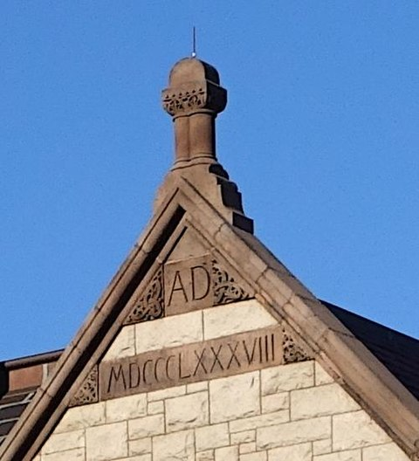

Note that the date is the end of the 19th century, until when this Western arithmetic inferiority still widely prevailed, and the place is the Boston Public Library near Cambridge, Mass., where the cream of American academics is located at Harvard, MIT and Radcliffe. But none of these worthies ever commented on the continued use of the extraordinarily inferior Greco-Roman arithmetic.

Because of this extraordinarily inefficient and inferior system of Western ethnoarithmetic, though early Greek and Roman number-names are similar to those in Persian and Sanskrit, they could barely count and were restricted to tiny numbers. Indeed, laughably, the largest number they named was a myriad, or 10⁴, which still connotes uncountably large in English according to the OED! This myriad is laughably puny compared to giant numbers like parardha (10¹²) and tallakshana (10⁵³) and beyond in ancient India. The important thing is this: the West stuck to its inferior system just because the best Western minds foolishly kept insisting for centuries that their primitive and inefficient way of doing arithmetic was superior.

Thus, the issue was not just one of naming larger numbers. Arithmetic operations on the abacus are extraordinarily inefficient compared to the algorithms of Indian place-value arithmetic. Doing arithmetic the abacus way may be some thirty times slower than doing it on the place-value system, even for the multiplication of some 2-digit numbers such as 89×79. But Western mathematicians kept chanting for centuries that their method was superior, superior, superior and stuck to it. Unlike the case of racist supremacy, where reversing the assertion may be called reverse racism, in this case, we can definitely assert that Western arithmetic was actually inferior, inferior, inferior.

The related inability of Greeks and Romans to manage basic arithmetic of fractions is reflected in the lousy Greek and Roman calendars, a version of the latter still in use. The inferior arithmetic system and the inferior calendar are solid non-textual evidence against the fantasies that the early Greeks achieved much in mathematics and science. That was just a post-Crusade fantasy concocted first for theological correctness, and later for self-glorification, using crooked evidence by backdating late Byzantine Greek texts to the time of early Greeks.

As is well known, the word algorithm comes from the Latin name of Al Khwarizmi. The Arabs, unlike the arithmetically challenged Romans, quickly recognised the huge advantages of Indian arithmetic, and imported and adopted both the decimal place value system used in everyday commerce AND the sexagesimal place-value system, used in Indian astronomy, since the earliest Vedas. This knowledge gathered by Arabs naturally spread to the Byzantine Greeks, and these late Byzantine Greek manuscripts from after the 8th c. are now used to glorify Greeks.

Attributing knowledge from Arabic books to the Greeks was a post-Crusade political necessity, since knowledge was necessary to win the Crusades, and all the early European universities (Oxford, Cambridge, Paris, etc.) started during the Crusades with knowledge grabbed from Muslim libraries, which knowledge had to be somehow proved to be of theologically correct origin. The early Greeks were regarded as the sole friends of Christians since Eusebius. So this false attribution to Greeks enabled all this knowledge to be declared a Christian inheritance. During the fanaticism of the Crusades, no one noticed the lack of evidence.

Later racist historians attributed all knowledge from Black Egypt to White Greeks to glorify Whites as the originators of all knowledge. And still later (after the Aryan race fantasy that India was conquered and populated by Whites), these “Greeks” were reinterpreted not as Whites, but as civilizationally a part of the West. (This trick of using false history was not invented during the Crusades. It goes back to the 5th c, Orosius who used Christian chauvinist history (History Against the Pagans) to promote Christianity, that, according to that history, Christians were rewarded and “pagans” punished in this very life, not merely in a future life after death,)

Anyway, the sole evidence for all this fake history of Greek achievements are these late Byzantine texts anachronistically attributed to early Greeks such as Archimedes, whose face is depicted on the Fields medal. Of course, Black Egyptians knew the volume of the cylinder a thousand years before any notable Greeks, but this is dismissed in the usual way of racist history, without asking how the Greeks could do science with their bad arithmetic.

(I should add that the Babylonians too no doubt had sexagesimal arithmetic, but there is no evidence for the fairy tale that the early Greeks suddenly learnt this from them, and then magically this knowledge completely vanished just as suddenly, or maybe turned into a pumpkin like Cinderella’s carriage, and was then equally magically recovered absolutely intact after a thousand years. However, there IS ample evidence that Indian arithmetic went to the Arabs and that Arabic knowledge was transmitted to Byzantine Greek texts before the use of minuscule, different from early Greek writing.)

Anyway, through the Umayyad Caliphate, this knowledge of Indian arithmetic came to Spain, which Muslims ruled. Unable to bear Muslim taunts that backward Christians barely knew how to count, Gerbert, later Pope Sylvester II, decided to learn this Indian system from Muslims. Alas, all he could manage was to represent large numbers on a huge abacus with 27 columns, adding his trivial innovation of apices. (Apices are a system where a counter with the number, say, 4 written on it replaces 4 counters.) Specifically, the infallible pope completely failed to grasp that the Indian arithmetic system carries out arithmetic operations in a different and far more efficient way using the place value system.

Not Gerbert alone, but Europeans in general were exceptionally slow, like duffers in the math class, to grasp superior Indian arithmetic, and it took all of two centuries before Fibonacci, a Florentine trader, who learnt it from Muslims, this time in Africa (Algeria), grasped that efficient Indian arithmetic is very useful for commerce. However, the rest of Europe was very slow to understand this; it rejected zero and treated this Indian arithmetic as a Florentine idiosyncrasy. While Fibonacci improved on Gerbert, he too failed to fully understand subtraction, saying in his Liber Abaci, that only smaller numbers could be subtracted from larger ones. This gross European error persisted.

Indian arithmetic really started spreading in Europe only after the 16th c., after poor Europeans started flocking in droves to India, hoping to grab a piece of its legendary wealth, like those who flock to the US today. It was after this that the Jesuits recognized that European ignorance of arithmetic limited their knowledge of astronomy (hence navigation), and started teaching “practical arithmetic” in the Jesuit syllabus starting around 1575. The label “practical” was intended to underline its inferiority and separate it from the supposedly superior spiritual and impractical arithmetic of Boethius still taught in the church quadrivium.

Note that the mess of the Roman calendar is due to the lack of precise fractions (with large numerator and denominator) in Roman arithmetic. The Gregorian calendar reform of 1582 still avoided precise fractions to state the average duration of the tropical year, since fractions (impossible with Roman numerals) were little known even then in barbaric Europe, and the calendar reform used a complex and confusing system of leap years, to avoid fractions. It was at about this time that Indian decimal fractions were introduced in Europe by Simon Stevin via al Kashi, and earlier al Uqlidisi.

But European difficulties in understanding Indian arithmetic persisted until the 19th century, with Pascal hilariously claiming that 0-4=0. These difficulties plagued leading European minds for 9 centuries, from Gerbert to Fibonacci through Pascal, Euler, and Augustus De Morgan, all of whom struggled to understand the negative numbers of Indian arithmetic. The meaning of negative numbers was quite clearly spelt out by Brahmagupta as debt and by Bhaskara as “in the other direction” (as with latitude and longitude). But it was too difficult for European mathematicians to grasp until the end of the 19th c. The full story is told in my book, The Funny History of Arithmetic, a story of protracted European foolishness and inferiority in arithmetic, which story the West doesn’t want to be told.

Thus, this is what De Morgan wrote in the 19th c.: that 10 − 11 is impossible. The West enforced its stupid lies of “superior” knowledge through physical force during colonialism.
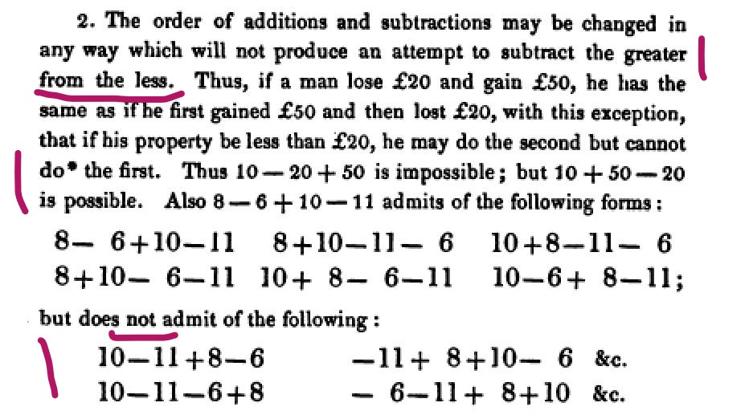

If you really believe the declaration of these 25 Field medallists that there is only one kind of mathematics, namely the kind above, or the padreist teaching that this Western ethnomathematics in which 10 − 11 is impossible is “superior”, then go ahead and endorse the appeal. Let your children grow up believing they are inferior to the West because 11 can’t be subtracted from 10. If not, then like Black slaves, this is the time for colonial mental slaves to strike out for emancipation without waiting for any civil war or emancipation bill to be signed by a Westerner.

To summarise, for thousands of years until the end of the 19th century the West was amazingly backward and inferior even in elementary arithmetic. (All the stories that you may have heard about early Greek achievements are based on false and Christian chauvinist history; the chauvinistic backdating of late Byzantine Greek texts.) The real fact is that even after importing superior Indian arithmetic in the 10th century, for its practical value, the top minds in the West struggled and struggled and struggled for centuries even to understand elementary subtraction till the 19th century. Why? Because they laughably hung on tight to their hubris that whatever they did, no matter how primitive or stupid, was “superior”. Hence, no credibility should be attached to their claims of present-day superiority of Western ethnomathematics, the kind done by Fields medallist, which superiority is political rather than practical.

Similar issues arose because of the persistent Western misunderstanding of Indian calculus and even algebra as summarised later.

Why axiomatic mathematics CANNOT provide practical value: it prohibits the empirical

But the immediate question is whether the purported superiority of Western ethnomathematics (axiomatic mathematics) as asserted today is as stupid a claim as the purported superiority of its pebble arithmetic being asserted till the 19th c.?

Indeed, that is so. And there is a fundamental structural reason why axiomatic mathematics, i.e. Western ethnomathematics (unlike Indian ganita), is inferior and cannot provide practical value, just as there was a structural reason for the immense backwardness of Graeco-Roman pebble arithmetic.

The reason is that axiomatic mathematics prohibits the empirical and is therefore pure metaphysics, or rather non-physics, which may be completely unrelated to reality. That formal mathematics prohibits the empirical seems surprising to some; but it only shows they didn’t read their school math texts, for this prohibition of the empirical is stated even in the Indian Class 9 school text.

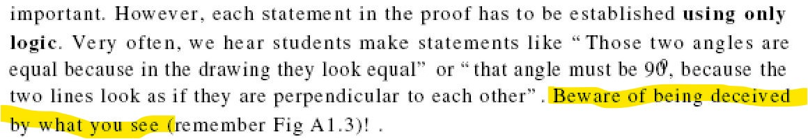
The same thing can be found in the definition of (axiomatic) mathematical proof in any text on mathematical logic, and I have been pointing this out for a quarter of a century, that the uniqueness of Western ethnomathematics is not in the use of deductive reason, but in the prohibition of the empirical. That is, an axiomatic mathematical proof cannot include any statement of the sort that “I observe this, therefore it is true”. This is why AI, which has no access (as of now). to real-world facts can do axiomatic math so well.

This tricky method of proof, which prohibits the empirical, was invented by the padres to support of their crusading Christian theology of reason. For example. Aquinas proved his angel theorem axiomatically. The grand theological fallacy was, as in the case of Boethius, that since empirical observations may be erroneous, conclusions arrived at by deductive reasoning, which prohibits the empirical, are absolutely certain! The political point of such theological reasoning, which prohibits the empirical, similar to the reasoning used in axiomatic math, was that the conclusions (theorems) can be tailored to suit what one wants by making the appropriate politically convenient postulate, as Aquinas did.

This is a fallacy firstly for the simple reason that while the empirical is fallible, the exclusion of the empirical does not make something infallible, as theologians believed! Eventually, even Europeans accepted that scientific reasoning, which accepts the empirical, as does ganita, even though fallible, is far more reliable than theological reasoning and its fantasies about angels.

But this is a fallacy and a padreist superstition also for a deeper reason: it is claimed that prohibiting the empirical adds epistemic value (leads to greater certainty), even if it fails to provide practical value. But epistemic value according to which philosophy? Obviously, padreist theology.

Thus, in stark contrast, every system of Indian philosophy, without exception, accepts the empirically manifest (प्रत्यक्ष प्रमाण) as the first means of proof, as does science. Further, contrary to the Western dogma that deduction leads to certain truth, there are schools of philosophy such as the Indian Lokayata, which rejected deductive inference as an invalid, fallible, and inferior means of proof. Why? Because from wrong premises, an invalid conclusion may be deduced.

An easy example is provided by my rabbit theorem. If one assumes (1) that all animals have two horns, (2) that a rabbit is an animal, then the deduced conclusion is the absurdity (3) that all rabbits have two horns. But to reject this reasoning one needs to point to the empirical fact that not all animals have two horns. (But the empirical is prohibited in axiomatic mathematics and theology.) Note that such theological “deductive reasoning”, which prohibits the empirical, is not the kind of reasoning used either by science or by Sherlock Holmes both of which use facts.

The Lokayata critique of deductive reasoning is right, and a matter of common sense. The deduced conclusions are only as true as the axioms. (BTW, even the Class 9 Indian school text admits that the word axiom does not mean “a self-evident truth” but nowadays means postulate, or an assumption.) Thus, the theorems of axiomatic mathematics are not valid truths in the real world. Mathematical theorems are at best relative truths (relative to axioms AND logic). Setting aside the deeper question of logic, or why two-valued logic should be the basis of mathematical theorems, especially in probability and statistics, let us look at just the axioms.

Most axiomatic mathematics today is founded on the axioms of set theory. All the theorems proved by AI use those axioms of set theory, as cross checked by LEAN. But do you know of any famous experiments used to test the validity of the axioms of set theory? No? There cannot be! There is no way to empirically test their validity in the real world because the axioms involve metaphysics (i.e., non-physics) typically a metaphysics of infinity, untestable since non-existent in the real world. The axioms of Western ethnomathematics are decided purely by authority of the “mathematics community”, not by testing axioms by experiment, to test whether they apply to the real world. It is no coincidence that the metaphysics of infinity in math is closely aligned to church dogmas of eternity.

As the simplest possible example, consider the invisible geometric points of the Indian Class 6 text.
Though invisible points are a part of the metaphysics of the church quadrivium not of axiomatic mathematics per se, but a Class 6 student cannot be expected to know the difference. Invisible points have been very much retained in the revised Class 6 text, revised by the Fields medallist Manjul Bhargava.

So, what experiment or observation can children use to test the truth of the axiom that there is a unique invisible straight line through two invisible points? Through two visible points, which some finite size, one can always draw more than one straight line. This does not prevent dishonest mathematicians from lying with the help of pliable journalists to fool common people that the empirical is not prohibited in axiomatic mathematics. Since the empirical is prohibited, one must disregard one's experience and accept the axioms by blindly relying on authority, which is highly fallible, even when not outright dishonest.

Because the axioms of set theory are no part of the real world, neither are the theorems. For example, the theorem of set theory, such as the Banach-Tarski theorem, do not apply to the real world. On the Banach-Tarski theorem, a ball of gold may be subdivided into a finite number of pieces which may be reassembled without stretching into two balls of gold identical to the first. Anyone who believes this mathematical theorem is true in the real world should apply it to get rich quick. Or let us admit the Lokayata was right in saying that the deduced theorems of mathematics are not valid knowledge in the real world.

There are other ways in which a deduced mathematical theorem may be false, One may wrongly believe an erroneous proof is valid, as has happened with many great mathematicians who fantasised that they had a proof of, say, the Riemann hypothesis. How do YOU know whether a long and complex mathematical proof such as Russell's 378 page proof of 1 + 1 =2 is valid? Not even a typo in it? One does not know. To check, either one trusts Russell's authority or one checks and rechecks the proof, which repeated checking is a process of induction, which too is fallible. Even after one has checked it ten times, there may still be a mistake lurking somewhere. That there is no such mistake is a belief based on infallibility of authority. So everything in axiomatic mathematics, as in the Crusading Christian theology of reason, is decided by authority which is highly fallible, far more fallible than empirical proof.

Since everything in axiomatic mathematics is based on authority, it is also well to ask how honest is this mathematical authority? Is this demand for trust in authority a matter of faith in con-tricksters like those who produced the emperor’s “beautiful” new clothes?

We especially need to ask this question given that Western ethnomathematics imitates Christian theology, so could mathematical authority be as dishonest as the padres?

How honest is mathematical authority? How a Fields medallist brazenly plagiarised my research

Can mathematical authority be trusted? Thus, consider the infamous case of Michael Atiyah, who was both a Fields medallist and an Abel laureate. (The Abel prize pays some USD 800K, compared to some USD 10K of the Fields medal.) Atiyah in his Einstein Centenary lecture of 2005, celebrating the publication of Einstein's special relativity paper in 1905. brazenly tried to grab credit for my earlier published and publicised correction to Einstein's mistake in understanding special relativity. (This was not a mistake in the theory of special relativity itself, a brilliant theory created by Poincaré, whose ideas Einstein stole.) Atiyah was caught when a repeat of his lecture was also video recorded and live-streamed. He was immediately informed about my earlier published books and papers (from 1992-94, 20003, 2004), and acknowledged those emails.

My point in exposing Einstein's mistake was nothing personal as has been misrepresented; it was to point out that if the mathematics of physics, after special relativity, was done correctly, it could explain most of the mysterious features of quantum mechanics. Common people who have no knowledge of relativity but who have only heard numerous stories of Einstein’s “greatness”, believe the story, and find it impossible to accept that a mere brown-skinned Indian could spot a mistake made by Einstein and many others.

Common folk want confirmation by social authority. But Atiyah was himself an authority, a successor to Newton as the president of the Royal Society, and he certainly understood the easy part of my mathematical argument (about history dependence), the part which was known to mathematicians since Poincaré, though not much applied to physics. If Einstein, an unknown patent clerk, could steal from the famous Poincaré, why could Atiyah not steal from a little-known Indian?

So, Atiyah went ahead and falsely claimed ownership of my idea by (a) saying "don't forget that I suggested it" while (b) suppressing any mention of my past publications. This credit grab was NOT due to any oversight or unfamiliarity with my publications. This is amply proved by the fact that Atiyah very deliberately and brazenly went ahead and did it AGAIN, a second time, a year after he was repeatedly informed of my earlier work (and acknowledged the emails). That is, he repeated his claim of ownership of my idea while again suppressing any mention of my past publications, with a view to grab credit for himself.

This second time was in an article reporting on the same Einstein Centenary lecture, but now published prominently in the Notices of the American Mathematical Society (AMS), a year after Atiyah had been personally informed of my publications which he should have known anyway, for they were not only published but were widely publicised. The Notices, by the way, is the math journal which is most widely read by professional mathematicians or axiomatic mathematicians.

Atiyah again claimed credit for my correction to Einstein's mistake which may yet prove to be the right way to understand quantum mechanics. To this end, he got (part of) my idea named after him as "Atiyah's hypothesis". He was again quoted as saying, "Don't forget that I suggested it". He again feigned ignorance of my earlier work, which was again not mentioned, though he had even been personally informed of it. Indeed, the AMS ethics expects an author to be well informed and does not permit claims of "oversight" of earlier published work even once, for such ignorance may be easily feigned, and would legitimise widespread plagiarism.

But this second time, I did not let the matter pass, and started asking awkward questions. Eventually Atiyah was forced to acknowledge the physical existence of my closely related prior publications.

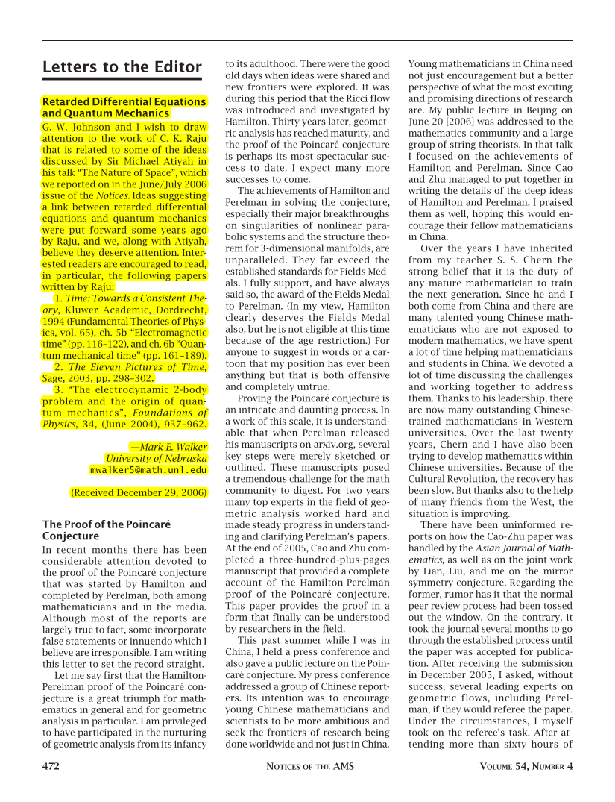

However, the physical existence of my earlier publications did not really need proof, and Atiyah did not apologise for his repeated violation of academic ethics as also the published ethics of the American Mathematical Society. He kept pretending it was an innocent oversight, an independent rediscovery! As a Fields medallist and an Abel Laureate, wasn't he special? Had he not earned the privilege to steal first and acknowledge later, that too only if and when he was squarely caught and escape was impossible? The then editor of the Notices of AMS, Andy Magid thought so, that the ethics of the AMS applied only to ordinary people and not to Fields medallists. He thought it is a myth that all are equal before the law. He refused to enforce the published ethics of the AMS or to ask Atiyah to apologise for his ethical misconduct on two occasions.

Apart from ethics, there was also an issue regarding wrong content. It was certainly socially savvy to use the term “Atiyah’s hypothesis” instead of my term “Einstein's mistake”, which enrages ignorant people brought up on stories of Einstein’s supposed greatness. However, the term ”hypothesis” is incorrect from the viewpoint of physics. I made no hypothesis, but only insisted that the mathematics of physics after special relativity, involving functional differential equations (as distinct from the ordinary or partial differential equations of pre-relativistic physics) should be done correctly. Indeed, as a reviewer of my book pointed out, progress in physics is usually made by dropping hypotheses. He noted (unlike Atiyah) that I had dropped the hypothesis of causality, thus going well beyond Poincaré too, and speaking of functional differential equations of mixed type, NOT merely retarded equations. The related little-known math is essential to explain non-locality in quantum mechanics, and the natural way to redo the 2-body problem of classical electrodynamics, from the difficulty of which quantum mechanics arose.

But, like so many knowledge thieves, Atiyah failed my epistemic test: he did not understand this part of my thesis, and the related little-known math, And, therefore, even the belated acknowledgement mentioned only retarded differential equations, which are obviously inadequate to account for the non-locality of quantum mechanics.

However, the editor of the Notices defended the crime, AND the erroneous content. He refused to publish my side of the story that the plagiarism had happened twice, the second time after Atiyah was repeatedly informed of my earlier published work, and that Atiyah had made a mistake in understanding my ideas, a mistake damaging to physics. The editor wanted unethically to suppress this fact from public view to maximise credit for Atiyah. He wanted that people should see only the "truth" he wanted them to see, presumably in the "interests of the mathematical community", or some other such vague criterion. Of course, he was completely indifferent to the interests of science and the physics community, and refused to correct the term “hypothesis”, or to point out that no hypothesis was needed, so that the term “Atiyah’s hypotheses”, tailored for Atiyah’s glorification, reflected a bad understanding of the subject.

Set aside the editor of the Notices, no one from the entire AMS, and no formal mathematician, ever protested this editorial decision lacking integrity, or responded to my "petition against celebrity justice", whose signatories included a Fellow of the Royal Society, asking for my side to be published or for the AMS ethics to be upheld.

An independent ethics body, the Society for Scientific Values, did investigate the matter and three experts it appointed agreed there was a prima facie case of plagiarism. For full details see the Atiyah page on my website. Finally, see my acceptance speech for the Telesio-Galilei award in Hungary.

In short, this is a case of academic misconduct by a Fields medallist endorsed and defended by the “mathematics community” (i.e., the Western ethnomathematics community). This experience, one of many with formal mathematicians, has naturally left me with a very poor opinion of the ethics of all formal mathematicians. If the mathematical authorities you trust are brazenly unethical, why should they not cheat for their personal benefit like ordinary human beings?

.

The lies and superstitions of the axiomatic math brought by colonial education
That this case is representative of Western ethnomathematics, not an outlier, is clear from the numerous myths and superstitions stuffed into the colonial teaching of axiomatic mathematics.

Thus, the above-cited Class 9 school text goes on to teach the lie that only the West used “reason” in mathematics. Implanting this sort of lie, as part of childhood indoctrination, is the real reason why the padres/coloniser needed to control education.

Certainly, Indian mathematics used deductive reasoning in proofs, as in its proof of the “Pythagorean” theorem, or in Aryabhata’s deduction (Gola 6) that the earth is round like a kadamba flower. The Naiyayikas, Buddhists, etc., explicitly accepted deductive inference as a valid means of proof. But all Indian thought also accepted the empirically manifest as the first means of proof, like science, but unlike Christian theology. That the earth is round was deduced from the observation that far-off trees cannot be seen, or that a ship disappears over the horizon, not from any metaphysical (i.e., non-physical) axioms. The school text wrongly perpetuates the theological fallacy equating the use of the empirical with the rejection of reason.

Why does the school text lie? Obviously with a view to confound and confuse students that theological reasoning (or reasoning MINUS facts) unique to the West is as valuable as, or more valuable than scientific reasoning (or reasoning PLUS facts), as used in ganita. Thus, scientific reasoning or reasoning in ganita, accepts the empirically manifest as a means of proof, while theology prohibits it to talk of things like god, angels, etc. for which no empirical evidence is possible, as for the axioms of set theory. But theological reasoning is the norm for Western ethnomathematicians.

The excuse may be offered that it is ignorance, not a lie; perhaps the colonised authors of the text never studied Indian ganita? But they lie also about Western tradition! So it is their intent to lie.

Thus, in actual fact, the kind of theological reasoning used in axiomatic proof (reasoning MINUS facts) originated for the political convenience of the Crusading church, hence was unique to the West. To mask its objectionable Christian theological origins, the school text tells another lie widespread among Western ethnomathematicians. This philosophy of axiomatic proof is falsely attributed to a mythical "Euclid", for whose existence there is no evidence (see my Euclid challenge prize).

Even more brazenly, axiomatic proofs are NOT found in (any version of) the "Euclid" book, as was wrongly taught at Cambridge university for centuries. The absence of axiomatic proof in the Euclid book was acknowledged only in the 20th century when Hilbert and Birkhoff gave two separate ways to provide the axiomatic proofs missing in the ”Euclid” book, but only at the expense of violently altering the “Euclid” book. The fact (“no axiomatic proof in the "Euclid" book”) contrary to the Euclid myth again exposed cebturies of Western foolishness in math, this time not in arithmetic but in geometry, a key aspect of Western ethnomathematics. Therefore, they rushed to do what the padres always did: when one lie is exposed, they tell another to cover it up, (This is called the method of piling on the hypotheses to save a sinking theory.) Since there are no axiomatic proofs in the “Euclid” book, the new lie that was invented was this: “the mythical Euclid intended axiomatic proofs even if he erred in not providing such proofs”.

Obviously, the padres, the dons of Cambridge, knew better than the author of the “Euclid” book what sort of book s/he intended, since the West concocted the myth of Euclid to suit its political purposes. This sort of fantasy storytelling, inventing long chains of fantasies, can go on forever.

Dishonest axiomatic mathematicians understand that it is easy to impute any motive to an unknown person, the mythical Euclid. But the unfortunate fact is that there is ample counter-evidence against axiomatic proofs in the “Euclid” book. The fact is that another (Neoplatonic) method using diagrams IS found in the book, which actually intended the diagrams as emphasised by Plato and confirmed by Proclus. And the book is obviously full of diagrams, which have a special significance in Plato's philosophy of mathematics, as a way to arouse the soul, but no significance in axiomatic proof, as Russell too pointed out. But axiomatic mathematics teaches one to not believe what one sees. Instead, one must trust whatever nonsense the “authorities” say that the profusion of diagrams in the book was never intended, and the author of the book was a complete fool, whose intentions axiomatic mathematicians better understood!.

Western ethnomathematicians fanatically support the church-imposed “reinterpretation” of the “Euclid” book as concerning the axiomatic proof used in post-Crusade Christian theology. Their whole discipline would crash and come into disrepute. if it were exposed that Christian theology, not some little-known Greek, is the origin of “superior” axiomatic proof. As explained in my books, Euclid and Jesus, how and why the church changed mathematics and Christianity across two religious wars, and The Eleven Pictures of Time, the church pronounced its greatest curse (anathema) against Neoplatonic beliefs popular even in early Christianity and also Islam, as in Sufism. Later, the Crusading church accepted the method of axiomatic proof just to support its politics against Islam during the Crusades: the Christian theology of reason created by Aquinas and the schoolmen in opposition to the Islamic theology of reason or the Aql-i-kalam. Unfortunately, Muslims across the world too got colonised, and have not understood this padreist trick: they still go by axiomatic mathematics, even in Iran, Even Chinese teach mathematics using the axiomatic method, not recognizing its theological origins.

Actually, lies about Euclid are not isolated. There is a much wider variety of myths and superstitions in the teaching of colonial mathematics or Western ethnomathematics, for example in the teaching of calculus. These are summarised in the abstract of my keynote last year to expose the myths and superstitions of axiomatic mathematics. A Fields medallist, Manjul Bhargava, was present. But neither he nor any of the other people present responded to the substance of this serious critique against axiomatic mathematics or Western ethnomathematics (the only kind which gets the Fields medal) and their myths and superstitions. The fact is that they have no valid response, hence they dodge debate, because they are committed to dishonesty on the basis of which they derive their power and privilege.

The harmful effects of axiomatic mathematics

Hardy was wrong in saying that (axiomatic) mathematics cannot be harmful like chemistry (used to make bombs). Its harmful effects are initially mental but physical in the long run. Thus, padres ruled Europe for over one and a half thousand years without weapons. Their power was based on mind capture using lies and superstitions, which they systematically spread through the education system, very much like the above lies and superstitions spread by post-colonial Western ethnomathematics. The related assertions of supremacy led to the greatest evils known to the world: crimes of vast genocides (in 3 continents), slavery (of people from a fourth continent), racism, and colonialism (across the world). Therefore, this sort of power based on lies and superstitions can cause huge harm in the long run.

The privileges derived by a few- the West in the case of colonialism, the Whites in the case of slavery, etc., or Western ethnomathematicians- all derive from these lies and superstitions. If Western ethnomathematicians do not intend that harm, then they should oppose these lies and superstitions. Instead, they support and preserve these lies and superstitions together with their assiduous attempts to cover up any exposed lies by inventing brazen new lies (“Euclid intended axiomatic proofs even if he did not give them; we must believe this because the padres say so and we must believe them and not believe what we see: the diagrams in the book”). Hence they dodge debate on them.

This capture of the colonised mind, or mental slavery, was essential for the success of colonialism, especially in countries like India, where colonial military power was very weak compared to that of Indians. This weakness of British military power in India is shown by the ease with which it was overthrown across the country in 1857, and the way the British governor earlier begged for pardon by prostrating himself at the feet of Aurangzeb. Note that right from Mughal times it was the Indians who had better steel technology, better guns, and a monopoly on rockets used to defeat both Jehangir in the Deccan and the British in Mysore. The British had no rockets but only their boast that 10−11 is impossible in their “superior” mathematics, which was actually a pretty inferior and lousy kind of mathematics for rockets,

How axiomatic mathematics corrupts science

One little-known harm due to these lies and superstitions in axiomatic mathematics is the way axiomatic mathematics corrupts science. In science, unlike mathematics, one cannot assume anything one likes. The assumptions must be empirically grounded. But they are not as in the “science of Stephen Hawking, whose co-author G. F. R. Ellis attacked me in South Africa. Recall the point mentioned briefly earlier that even the Nobel Prize for physics involves politics and was recently given for the mathematics of singularity theory, which has been used to promote Christian creationism, and even to fanatically claim that Judeo-Christian theology is part of physics, by those who boast of their many articles in Nature, and that this rePutability rather than refutability is the true test of science.

Now the mathematical problem of singularities in physics is often that of making sense of the differential equations of physics when a discontinuity develops, such as a shockwave. I solved this problem as part of my PhD thesis, within axiomatic mathematics, by using the then newly developed technique of non-standard analysis applied to the Schwartz theory of distributions. The Schwartz theory allows many discontinuous functions to be infinitely differentiated. Some years later I derived the most general form of the junction condition in general relativity, needed to continue a solution across a discontinuity. What this means is that a singularity may not be the beginning of the world or its end and it may just be the result of a bad Western understanding of calculus. Since this is a highly technical aspect of axiomatic mathematics, during a visit to the University of Cape Town, to speak on decolonisation, I suggested that I could discuss this separately in the mathematics department, where Ellis was the top dog.

My offer of debate frightened Ellis out of his wits, first because he lacked the technical competence for this level of formal mathematics, and was afraid that he would be exposed in front of his own people.

But how was this debate related to decolonisation? Calculus is needed to understand the differential equations of physics. My well-known thesis regarding calculus is as follows. The bad Western understanding of calculus arose because Gregory, Newton, and Leibniz falsely claimed they “discovered” the very same infinite series known centuries earlier in India. As is common with knowledge thieves, they failed to fully understand what they stole. That is, they did not understand how to sum infinite series. (Forget about infinite series; the top European minds like Pascal and Euler were struggling pitiably with negative numbers, and small sums like 10−11, until the 19th c.)

In the case of calculus, basically Europeans failed to understand Indian polynomial arithmetic, which is non-Archimedean, and which was used to sum infinite series such as the infinite geometric series first summed in India. My point of decolonising calculus was that as regards the differential equations of physics at a discontinuity or a singularity, instead of non-standard analysis applied to Schwartz distributions, I earlier used in axiomatic mathematics, it was enough to revert to pre-colonial Indian “non-Archimedian” arithmetic. (Bear with the fake inclusion of Archimedes in describing this arithmetic; it is mandatory in the West to attach a Greek or Christian name to everything.)

But there was a much deeper reason for Ellis’ extreme anxiety, as a church leader. As explained in detail in my book, The Eleven Pictures of Time, Hawking and Ellis used the method of axiomatic mathematics. That is, they used a postulate (=axiom) called the chronology condition to derive their conclusion of a singularity, falsely claiming a singularity as a consequence solely of general relativity. More amazingly, this chronology condition is is justified using arguments identical t those used to justify the church curse on “cyclic” time. That is these are exactly the wrong argument used by Augustine to transform post-Nicene Christianity and its notion of soul. Augustine's argument involved a lie, a gross misrepresentation of the pre-Nicene Origen (who first tried to standardize the Bible by comparing it in six different languages).This was Ellis’ deeper worry: that not only his personal scam but the whole scam of Augustine and post-Nicene Christianity would be out in the open.

Therefore, he did what church padres always do to tackle “heretics” who contest their fantasies. Ellis gathered together a church mob, its journalistic resources etc., and used his student, a professor of mathematics, to launch a personal attack on me, making all sorts of wild allegations without addressing a word of the substance of my critique, whether in mathematics or in theology. He assumed that everybody in his constituency would be so stupid as not to notice his failure to address the substance of my long-published critique and would never examine the truth of the wild allegations. (They did notice.)

However, the important point to note is that this is not just an isolated case of academic gangsterism in South Africa, where some people hate the mental emancipation from decolonisation, because it negatively impacts their sense of supremacy just as strongly as the KKK lynch mobs hated the physical emancipation of Black slaves.

Decolonised calculus and statistics

Nevertheless, it shows how the method of authoritatively asserting silly conclusions from weakly argued postulates is deeply rooted in Western culture, not only in the post-Crusade theology of Aquinas, but also in post-Nicene theology of Augustine. Allowing this method in mathematics (i.e., axiomatic mathematics), opens a backdoor to allow the most rotten sorts of padreist dogma to infiltrate and to corrupt science.

Therefore, the way to improve mathematics and get rid of these myths and superstitions and their ill effects on science. we need to decolonise. Here is an example concerning the teaching of calculus and statistics.

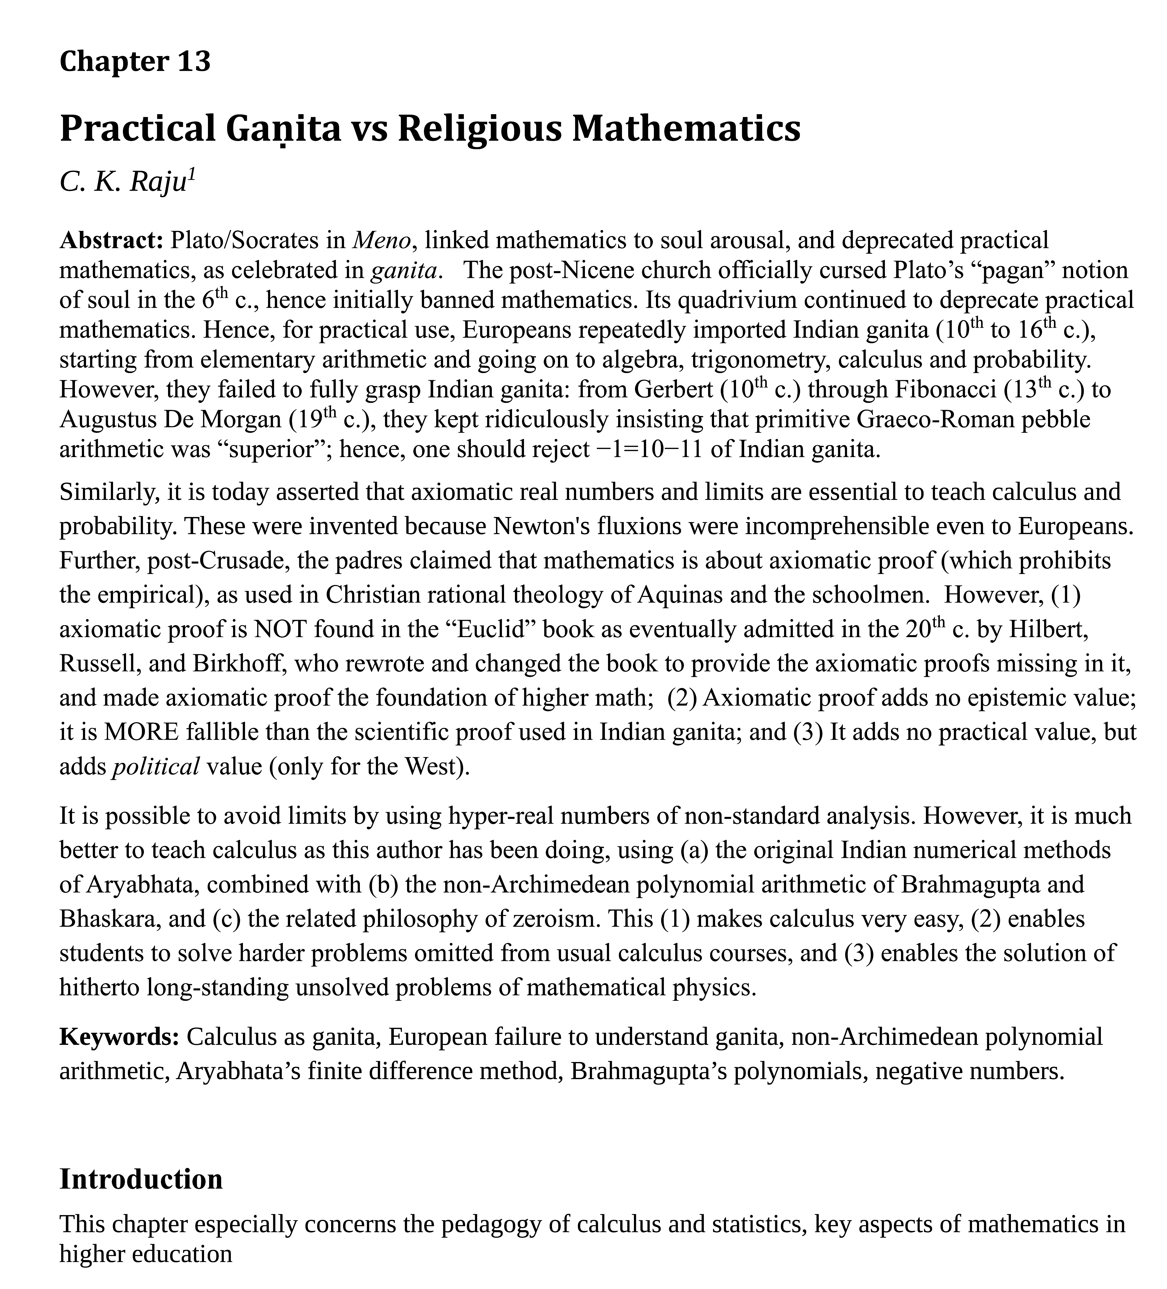

So mathematics can be made easy and of greater practical value, but the “mathematics community” (i.e., of Western ethnomathematicians) are determined not to allow it because it lessens their power and privilege, even if it improves the usefulness of mathematics to society. They don't care how much students suffer because of the added difficulties, any more than Inquisitors cared how much their victims suffered.

Endorsing their appeal to preserve the Western ethnomathematics community would preserve their powers and would condemn your children and grandchildren to the terror of mathematics and the power of a variety of myths and superstitions. Instead, we should all celebrate the fact that AI has exposed them, and shown the complete insignificance of these useless theorem-provers even in terms of theorem proving.

Concluding remarks
First, let me anticipate some of the Western and colonised responses to this counter statement, and explain how I am sure to win any real debate. In the West, the padreist dominance and the use of lies and superstitions meant that debate was to be avoided on, say, virgin birth, and, if unavoidable, it should be geared towards domination and propaganda. In contrast, the ancient Indian tradition of debate was geared towards truth. Therefore, in Indian tradition, such debate-dodging tricks (or non-response) were listed among the twenty-three ways of losing an argument. Note that responding only in a controlled forum where no further counter response is permitted, or is constrained, is also counted as a non-response.

1. To reiterate, the first Western trick is debate dodging, and failing that, censorship, to block the very articulation of the opponent's argument. Recall how my popular-level article “To decolonize math stand up to its false history and bad philosophy” went viral, was reproduced widely and then was censored across the world. No one thought it necessary to contest anything I had said: censorship by the ignorant White South African editor of the Conversation was the ultimate guide for people to be told what to believe. Obviously, the West was very unhappy with my critique, but no Westerner had the intellectual capacity to contest a single one of my claims. Therefore, censorship was the only option. However, in Indian tradition, such intellectual non-response, or the failure to address the opponent's arguments, is regarded as a sure way of losing the debate, because it is regarded as an admission that the arguments cannot be validly contested.

2. The second typical response is to make personal attacks. This method, a favorite of padres, was used by Ellis and his church gang. It is also the method used by colonised journalists and their colonised sponsors in India. On X, where such personal attacks are frequently made, I have characterised them as responses at the intellectual level of street dogs who are certain that a personal attack is a decisive intellectual victory! Let us see at what intellectual level these signatories are.

A typical personal attack is to portray me as a Hindu fanatic. No evidence was ever adduced from my writing to justify this “axiom” or “self-evident truth”, so this is an example of how axiomatic proof leads to nonsense conclusions. The corollary is that, as in the case of censorship, once such an allegation is made, there is no need to address any of the points I made because they are sure to be wrong. So such personal attacks greatly suit ignorant charlatans, who are completely unable to engage with the content of my critique, but want to make people believe it is wrong. How is this claim of Hindu fanaticism compatible with my consistent rejection of the teaching of Vedic mathematics and Vedic astrology? But remember, in axiomatic proof, facts don't matter!

Then there is the fact that in my books have been praised by people from a wide variety of religious denominations, and political beliefs: a Jew, an Afrocentrist, a Christian, a Hindu, a Bohra Muslim, a Marxist, a Pakistani Muslim, and two Western scientists and philosophers, all of whom carefully read and reviewed my work. But as already noted, facts don't matter to these believers in axiomatic proof, allegations/axioms do.

Obviously, these colonised fanatics and Christian chauvinists assert Hindu chauvinism, without reading or understanding or citing any my writings, or knowing my religious beliefs, Such exceptionally ill-informed and foolish responses are a sure sign of the intellectual victory of my critique. Let the street dogs bark and let us move on.

3. Of course, there are many other tricks of sophistry such as quibbles, misrepresentations (Bantuization, conspiracy theory polemic) and so on. All of these show that the polemicist is aware of his complete incapacity to intellectually engage with the substance of the critique. Therefore, I regard such polemics as a compliment and proof of the intellectual victory of my critique. So, let us move on from them as well.

4. Then there is the common fallacy of using one myth to prove another. For example, by saying that Hero of Alexandria cited Euclid: hence Euclid exists. This only shifts the onus of proof. Setting aside such weak-minded responses, a deeper trick of this sort is to cite the rare early papyrus which shows a geometric text somewhat similar to the “Euclid” book. This is fallacious for two reasons. Given Plato’s view on geometry and diagrams, such an early papyrus with diagrams must naturally be regarded as a Neoplatonic (religious) text, not as primary evidence for “Euclid”. Secondly, the differences from the currently “accepted” text show a lack of standardisation of this “Euclid” book even centuries after his purported date. That is, such papyri are evidence against Euclid’s authorship of the current text attributed to him. Indeed, as I have long argued, it was a Neoplatonist, the Black woman Hypatia, who gave the final form to an earlier existent book. But we all know that she was raped and lynched by a church mob, so the West will never accept her authorship.

5. So, will any of the 25 Fields medallists and 8000-odd endorsers address the key substantive issues? Why does axiomatic mathematics ban the empirical? How then can the axioms and theorems of axiomatic mathematics be checked? Is this prohibition a trick to enforce reliance on authority? Is reliance on authority less valuable than reliance on the empirical? Does prohibiting empirical facts in reasoning add or subtract epistemic value? Why is this method so similar to the method of reasoning in Christian theology invented during the Crusades? Any hypothesis other than mine that Crusading padres misinterpreted the “Euclid” book in a way politically convenient to their theology? To claim that their theological method originated with the early Greeks, not the immediate politics of Crusading theology? (I have yet to hear of any, maybe after and if the rage and personal hate attacks subside.)

Are these Fields medallists and endorsers so accustomed to the unquestioning acceptance of their authority that, like padres, they cannot speak two sentences without uttering a lie?. Why does the second sentence of the declaration speak of the “science of mathematics”? Is axiomatic mathematics really a science which is empirically refutable in terms of the Payasi-Poincare-Popper criterion of refutability? How does one empirically refute or verify the axioms of set theory? Science rests on the experimental method: if mathematics is science, do these signatories routinely suggest experimental tests of the theorems they prove? If the theorems of axiomatic mathematics are not true in the real world, could not its use result in dangerous pseudo-science? Are they just lying to pass off mathematics as a science when their long-stated belief, like that of Hardy, is that it is an art? Because there is more funding for science? Where in any of their published papers did any of these signatories use a statement in their proof that “we see this, therefore it is true”?

In short, do not expect axiomatic mathematicians (Western ethnomathematicians) to be honest any more than astrologers. There is a difference from astrologer and other con-tricksters: throughout the world, axiomatic mathematicians are supported by the state, unlike other con-tricksters who mostly run private enterprises.

To endorse their declaration is to endorse all the harmful myths and superstitions which are built into axiomatic mathematics, which these axiomatic mathematicians will never address.

In short, don't expect them to be honest. Don't expect them to acknowledge their errors. The only solution is that common people must unite to demand an end of state funding of Western ethnomathematics. It should also be banned from schools because it lacks secularism (like the Christian calendar) essential for a compulsory subject.

To reiterate, nobody should endorse their appeal. Let us instead celebrate how AI has exposed them and diminished their exaggerated sense of self-importance. Getting rid of them will help society, for they consume resources while giving nothing back to society. (And if theorem proving is of any value to society, let AI prove more and more theorems.) Getting rid of Western ethnomathematics will help our children by making math easy, and it will help technological advancement by enabling people to solve harder problems not solvable with axiomatic mathematics.

C. K. Raju, “गणित बनाम मैथमेटिक्स [Ganita vs Mathematics],” Himanjali 20, no. July-December (2020): 34–44.
NCERT Class IX. Mathematics. Here and elsewhere when I refer to the Class 9 text I will mean the one commissioned by the earlier UPA government, and edited by the committee headed J.V. Narlikar, P. Sinclair, and used until about a year ago. The new one is not quite ready yet.
C. K. Raju, “‘Euclid’ Must Fall: The ‘Pythagorean’ ‘Theorem’ and the Rant of Racist and Civilizational Superiority — Part 1,” Arụmarụka: Journal of Conversational Thinking 1, no. 1 (2022): 127–56, https://doi.org/10.4314/ajct.v1i1.6.
A. N. Whitehead and B. Russell, Principia Mathematica (Cambridge University Press, 1927).
C. K. Raju, “Statistics for Social Science and Humanities: Should We Teach It Using Normal Math or Formal Math?,” October 11, 2020, video: https://www.youtube.com/watch?v=A9Og1k-Z5O4?t=662. Presentation: http://ckraju.net/papers/presentations/statistics-jnu.html#slide-org948751a/
T. B. Macaulay, “Minute on Education,” 1835, http://www.languageinindia.com/april2003/macaulay.html#minute.
C. K. Raju, “Modi, Macaulay, and Padreism,” Countercurrents, December 13, 2025, https://countercurrents.org/2025/12/modi-macaulay-and-padreism/.
Raju, “‘Euclid’ Must Fall.”
Josiah Priest, Bible Defence of Slavery: To Which Is Added a Faithful Exposition of That System of Pseudo Philanthropy, Or Fanaticism, Modern Abolitionism ... and Proposing a Plan of National Colonization (W.S. Brown, 1851). See, also C. K. Raju, “‘Euclid’ Must Fall: The ‘Pythagorean’ ‘Theorem’ and The Rant Of Racist and Civilizational Superiority — Part 1,” Arụmarụka: Journal of Conversational Thinking 1, no. 1 (2022): 127–55, https://doi.org/https://dx.doi.org/10.4314/ajct.v1i1.6.
trans Dana C. Munro, Translations and Reprints from the Original Sources of European History, No. 3, The Medieval Student, II: No. 3 (University of Pennsylvania Press, 1897).
Raju, “Modi, Macaulay, and Padreism.”
T. B. Macaulay, Speech to the House of Commons, 18 April 1847, IV, Speeches of Lord Macaulay (1847), http://www.gutenberg.org/files/2170/2170-h/2170-h.htm#2H_4_0031.
C. K. Raju, “Computers, Mathematics Education, and the Alternative Epistemology of the Calculus in the YuktiBhâsâ”,” Philosophy East and West 51, no. 3 (2001): 325–62, https://doi.org/https://muse.jhu.edu/article/26555/pdf.
Raju, “Computers, Mathematics Education, and the Alternative Epistemology of the Calculus in the YuktiBhâsâ”.” For a video of the updated C++ program see
C. K. Raju, “A Singular Nobel?,” Mainstream 59, no. 7 (2021), http://www.mainstreamweekly.net/article10406.html. C. K. Raju, “Decolonising Mathematics: How and Why It Makes Science Better (and Enables Students to Solve Harder Problems),” Palestine Technical University Research Journal 6, no. 2 (2018): 1–4.
C. K. Raju, “The Christian Propaganda in Stephen Hawking’s Work,” Lifestyle, DNA India, January 16, 2011, https://www.dnaindia.com/lifestyle/review-the-christian-propaganda-in-stephen-hawking-s-work-1495047. For the political response to avoid discussing my critique instigated by Stephen Hawking’s co-author G. F. R, Ellis through his student, see https://www.youtube.com/watch?v=o8wt5zzGndA.
Michael Masi, Boethian Number Theory: A Translation of the de Institutione Arithmetica (Studies in Classical Antiquity, vol. 6, 1983). Emphasis in bold added.
Dorothy V. Schrader, “DE ARITHMETICA, book I, of Boethius,” The Mathematics Teacher 61, no. 6 (1968): 615–28, https://doi.org/http://www.jstor.org/stable/27957920. .
C. K. Raju, The Eleven Pictures of Time: The Physics, Philosophy and Politics of Time Beliefs (Sage, 2003) chp. 2, The curse on “cyclic” time.
C. K. Raju, The Funny History of Arithmetic: How “Superior” Europeans Blundered for 900 Years to Learn Elementary Indian Arithmetic (“Arabic Numerals” (Kant Academic Publishers, 2026).
Brahmagupta, Brahma-Sphuta Siddhanta, ed. Ram Swarup Sharma Sharma (Indian Institute of Astronomical and Sanskrit Research, 1966).
C. K. Raju, Cultural Foundations of Mathematics: The Nature of Mathematical Proof and the Transmission of Calculus from India to Europe in the 16th c, CE (Pearson Longman, 2007).
C. K. Raju, “Probability in Ancient India,” in Handbook of Philosophy of Statistics, vol. 7, ed. Paul Thagard Dov M. Gabbay and John Woods, Handbook of Philosophy of Science (Elsevier, 2011), http://ckraju.net/papers/Probability-in-Ancient-India.pdf.
C. K. Raju, “India’s ‘Aryan’ Debate: How Ambedkar & Periyar’s Views Affected Caste Politics,” TheQuint, January 9, 2023, https://www.thequint.com/opinion/indias-aryan-debate-how-ambedkar-periyars-views-affected-caste-politics.
Cheikh Anta Diop, African Origin of Civilization: Myth or Reality, ed. Mercer Cook (Lawrence Hill and Co., 1974).
C. K. Raju, Is Science Western in Origin?, Dissenting Knowledges Pamphlet Series (Multiversity, 2009).
C. K. Raju, Indian Calendar: Scientific Aspects (Kant Academic Publishers, 2024), https://play.google.com/store/books/details?id=ul0jEQAAQBAJ. This sexagesimal system was in use in Indian astronomy and timekeeping since the Vedanga Jyotis and is still in use.
George James, Stolen Legacy, ed. Molefi K. Asante (African American Images, 2001).
Martin Bernal, Black Athena: The Afroasiatic Roots of Classical Civilization., 1: The fabrication of ancient Greece 1785-1985 (Free Association Books, 1987).
Paulus Orosius, Seven Books of History against the Pagans : The Apology of Paulus Orosius, trans. Irving W. Raymond, Records of Civilization, Sources and Studies; No. 26 (Columbia University Press, 1936), WorldCat, https://www.attalus.org/info/orosius.html.
M. Clagett, Ancient Egyptian Science: A Source Book, Vol. 3 Ancient Egyptian Mathematics (American Philosophical Society, Philadelphia, 1999), RMP. Also https://x.com/CKRaju14/status/1983866076674060292.
D. H. Fowler, “Logistic and Fractions in Early Greek Mathematics”,” in Classics in the History of Greek Mathematics, ed. Jean Christianidis, Boston Studies in the Philosophy and History of Science (Springer, 2004).
N. Bubnov, Gerberti, Silvesteri II papae, Opera Mathematica (972-1003 (R. Friedlander & Sohn, 1899).
L. E. Sigler, Fibonacci’s Liber Abaci a Translation into Modern English of Leonardo Pisano’s Book of Calculation (Springer, 2002).
Christoph Clavius, Arithmeticae Practicae [Practical Arithmetic] (Dominici Basae, 1583). E. C. Philips, “The Proposals of Father Christopher Clavius, SJ, for Improving the Teaching of Mathematics,” Bull. Amer. Assoc. Jesuit Scientists (Eastern Section) 18, no. 4 (1941): 203–6.
pope Gregory, “Inter Gravissimas,” 1582, https://www.bluewaterarts.com/calendar/NewInterGravissimas.htm.
Vera Sanford, “La Disme of Simon Stevin—the First Book on Decimals,” The Mathematics Teacher 14, no. 6 (1921): 321–33.
Brahmagupta, Brahmasphutaddhanta (n.d.),, chp, 18.
H. T. Colebrooke, The Algebra of Brahmegupta and Bhascara (John Murray, 1817).
Raju, “Computers, Mathematics Education, and the Alternative Epistemology of the Calculus in the YuktiBhâsâ”.”
Thomas Aquinas, Summa Theologica (n.d.), http://www.newadvent.org/summa/1052.htm#article3.
Satish Chandra Vidyabhushana, The Nyaya Sutras of Gotama (Pāninī Office, 1913).
Haribhadra Suri, ed., षटदर्शन समुच्चय, 5th ed. (Bharatiya Jnanapeeth, 2000).
C. K. Raju, “Eternity and Infinity: The Western Misunderstanding of Indian Mathematics and Its Consequences for Science Today,” American Philosophical Association Newsletter on Asian and Asian American Philosophers and Philosophies 14, no. 2 (2015): 27-33.
C. K. Raju, “Decolonising Mathematics,” Alternation 25, no. 2 (2018): 12–43, https://doi.org/10.29086/2519-5476/2018/v25n2a2.
G. W. Johnson and Mark E. Walker, “Sir Michael Atiyah’s Einstein Lecture: ‘The Nature of Space’’,” Notices of the American Mathematical Society 53(6) (2006): 674–78.
J. Woodward, “Book Review: Time: Towards a Consistent Theory,” Foundations of Physics 26, no. 12 (1996): 1725–32.
C. K. Raju, “The Electrodynamic 2-Body Problem and the Origin of Quantum Mechanics,” Foundations of Physics 34, no. 6 (2004): 937–62, https://doi.org/10.1023/B:FOOP.0000034223.58332.d4. C. K. Raju, “Functional Differential Equations. 6: Quantum Mechanics,” Physics Education (India) 32, no. 1 (2016), https://doi.org/http://www.physedu.in/uploads/publication/22/369/11-FDEs-in-physics-6-(1).pdf.
http://ckraju.net/papers/presentations/images/Proof-table.html.
Raju, “Computers, Mathematics Education, and the Alternative Epistemology of the Calculus in the YuktiBhâsâ”.”
Āryabhaţa, Āryabhaţīya of Āryabhaţa, ed. K. S. Shukla and K. V. Sarma (Indian National Science Academy, 1976).
Vidyabhushana, The Nyaya Sutras of Gotama. Verse 2.
Bina Chatterjee, trans., Śişyadhīvrddhida Tantra of Lalla, 2 vols. (Indian National Science Academy, 1981).
https://ckraju.net/geometry/cambridge-note.html.
David Hilbert, The Foundations of Geometry (The Open Court Publishing Co., La Salle, 1950), http://ckraju.net/geometry/Hilbert-Foundations-of-Geometry.pdf.
George D. Birkhoff, “A Set of Postulates for Plane Geometry, Based on Scale and Protractor,” Annals of Mathematics 33 (1932): 329–45.
Proclus, A Commentary on the First Book of Euclid’s Elements, trans. Glenn R. Morrow (Princeton University Press, 1970).
B. Russell, “The Teaching of Euclid,” The Mathematical Gazette 2, no. 33 (1902): 165–67.
Raju, “A Singular Nobel?”
C. K. Raju, “The Christian Propaganda in Stephen Hawking’s Work,” Lifestyle, DNA India, January 16, 2011, https://www.dnaindia.com/lifestyle/review-the-christian-propaganda-in-stephen-hawking-s-work-1495047. For the political response to avoid discussing my critique instigated by Stephen Hawking’s co-author G. F. R, Ellis through his student, see https://www.youtube.com/watch?v=o8wt5zzGndA.
F. J. Tipler, The Physics of Immortality: Modern Cosmology, God, and the Resurrection of the Dead (Macmillan, 1996); F. J. Tipler, The Physics of Christianity (Doubleday, 2007).
C. K. Raju, “Products and Compositions with the Dirac Delta Function,” J. Phys. A: Math. Gen. 15 (1982): 381–96; C. K. Raju, “Junction Conditions in General Relativity,” Journal of Physics A: Mathematical and General 15 (1982): 1785–97.
C. K. Raju, “Distributional Matter Tensors in Relativity,” in Proceedings of the 5th Marcel Grossman Meeting, ed. D. Blair and M. J. Buckingham (World Scientific, 1989), arXiv:0804.1998.
https://www.youtube.com/watch?v=ckbzKfRIi6Q, https://www.youtube.com/watch?v=vWdqR-z6jIc.
Whish, Charles M, “On the Hindu Quadrature of the Circle and the Infinite Series of the Proportion of the Circumference to the Diameter Exhibited in the Four Shastras, the Tantrasamgraham, Yukti-Bhasa, Carana Padhati and Sadratnamala”,” Trans. R. Asiatic Soc. Gr. Britain and Ireland 3 (1835): 509–23; Raju, “Computers, Mathematics Education, and the Alternative Epistemology of the Calculus in the YuktiBhâsâ””; C. K. Raju, Cultural Foundations of Mathematics: The Nature of Mathematical Proof and the Transmission of the Calculus from India to Europe in the 16th c. CE (Pearson Longman, 2007).
C. K. Raju, “Marx and Mathematics. 4: The Epistemic Test,” Frontier Weekly, September 8, 2020, https://www.frontierweekly.com/views/sep-20/8-9-20-Marx%20and%20mathematics-4.html.
C. K. Raju, “Calculus,” in Encyclopedia of Non-Western Science, Technology and Medicine, ed. Helaine Selin (Springer, 2016), http://ckraju.net/papers/Springer/ckr-Springer-encyclopedia-calculus-1-final.pdf. C. K. Raju, “Calculus Transmission,” in Encyclopedia of Non-Western Science, Technology and Medicine, ed. Helaine Selin (Springer, 2016), http://ckraju.net/papers/Springer/ckr-Springer-encyclopedia-calculus-2-final.pdf. C. K. Raju, “Zeroism,” in Encyclopedia of Non-Western Science, Technology and Medicine, ed. Helaine Selin (Springer, 2016), http://ckraju.net/papers/Springer/zeroism-springer-f.pdf.
https://ckraju.net/papers/Appendix-on-Origen.pdf, giving extracts from Origen’s De Principis.
C. K. Raju, “To Decolonise Maths, Stand up to Its False History and Bad Philosophy,” The Wire, 2016, https://thewire.in/75896/to-decolonise-maths-stand-up-to-its-false-history/.
C. K. Raju, “Nothing Vedic in ‘Vedic Maths,’” Comment, The Hindu, September 3, 2014, https://www.thehindu.com/opinion/op-ed/nothing-vedic-in-vedic-maths/article6373689.ece. “UGC recommendations for IKS, some lacunae”, https://www.youtube.com/watch?v=uk14Bjmm3cA,
C. K., Raju, , “Astrology as a Church Superstition (Original Title: ‘Astrology in University Education--Twenty Years After’),” Frontier, November 31, 2021, https://www.frontierweekly.com/articles/vol-54/54-18/54-18-Astrology%E2%80%93a%20Church%20Superstition.html. https://www.counterview.net/2021/09/astrology-church-superstition-western.html, Astrology in University Education in India - Sindh Courier, September 13, 2021, https://sindhcourier.com/astrology-in-university-education-in-india/
C. K. Raju, Euclid and Jesus: How and Why the Church Changed Mathematics and Christianity across Two Religious Wars (Multiversity and Citizens International, 2012).
For an example, from stochastic differential equations, see Raju, “Computers, Mathematics Education, and the Alternative Epistemology of the Calculus in the YuktiBhâsâ”.”

